First student

select only his info:

* select * from Student1

-- this will show the information name grade and course id

----------------------Show exam --------------

* ShowExam 1,1;

Show exam take 2 parameter ( std_id,Course_id)

The result

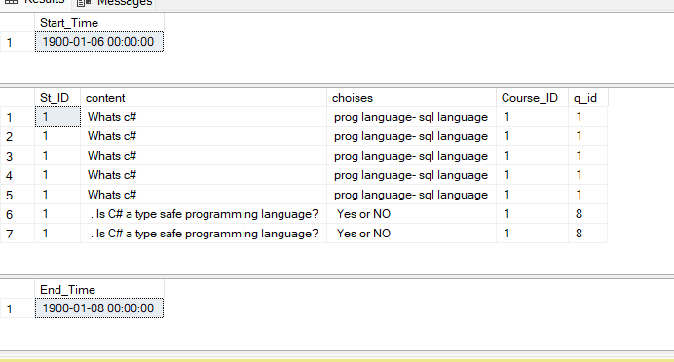

-------execute procedure Mark Every Result -------

* exec mark_every_question 'prog language',1,1,1
* exec mark_every_question 'Yes',4,1,1

-- Execute Procedure Store to show result with student id –

* showresult 1

the result

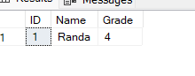

********************************************

Second Manager

********************************************

* EXEC PROC_AddInstructor 5, 'Sara', 1

--this will add instructor with name ‘sara’

* EXEC PROC_UPDATEInstructor 5, 'Eng:Sara',1

This will update an existing instructor

* EXEC PROC_DELETEInstructor 6

This will delete instructor

* EXEC PROC_AddStudent 51,Samoul,'.Net','Minya',43,'A',3,1
* EXEC PROC_DELETEStudent 2
* EXEC PROC_UPDATEStudent 1,'Hossam','Dot Net','assuit',43,'B',1,1
* EXEC PROC_AddCourse 21, 'Mysql-xampp', ' DATABASE lanaguge', 21, 40, 3
* EXEC PROC_DELETECourse 22
* EXEC PROC_UPDATECourse 21, 'sql', 'language database', 20 , 40, 2

******** see Views ********

* Select * from [TrackV]

This to select all columns in view named [TrackV]

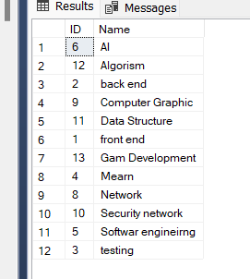

* select* from [BranchV]

result

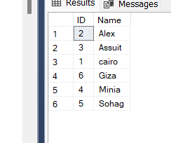

* select* from [BranchV]

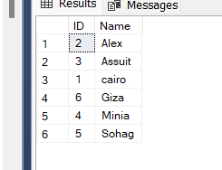

******************************************** Third Instructor

*******************************************

* Select * from [QuestionV]

The result

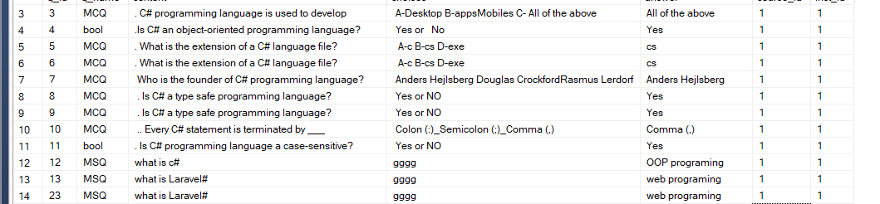

* exec InstructorAddQuetions 13, 'MSQ','what is Laravel#','gggg','web programing',1,1;
* exec instructorDELETEQUESTIONS 12;
* Make an exam
* exec makeExam 16,'AI','Alex',1,'msq','2023-07-24 06:30:50.000','2023-07-24 09:30:50.000',2022,2,1,1,4,1